This test will ran to see if my worksheet is good enough for managers, admins to use and see where any errors have occurred. I will be testing navigation buttons, input and error messages and more.

Test number | Test | Method of testing | Result | Amendments
1 | Navigation buttons | Clicking the buttons on the menu page to see if it takes me to the corresponding page | When I clicked on the button it took me to the page that it’s linked to. For example I clicked on the summary of information and it took me to that page. 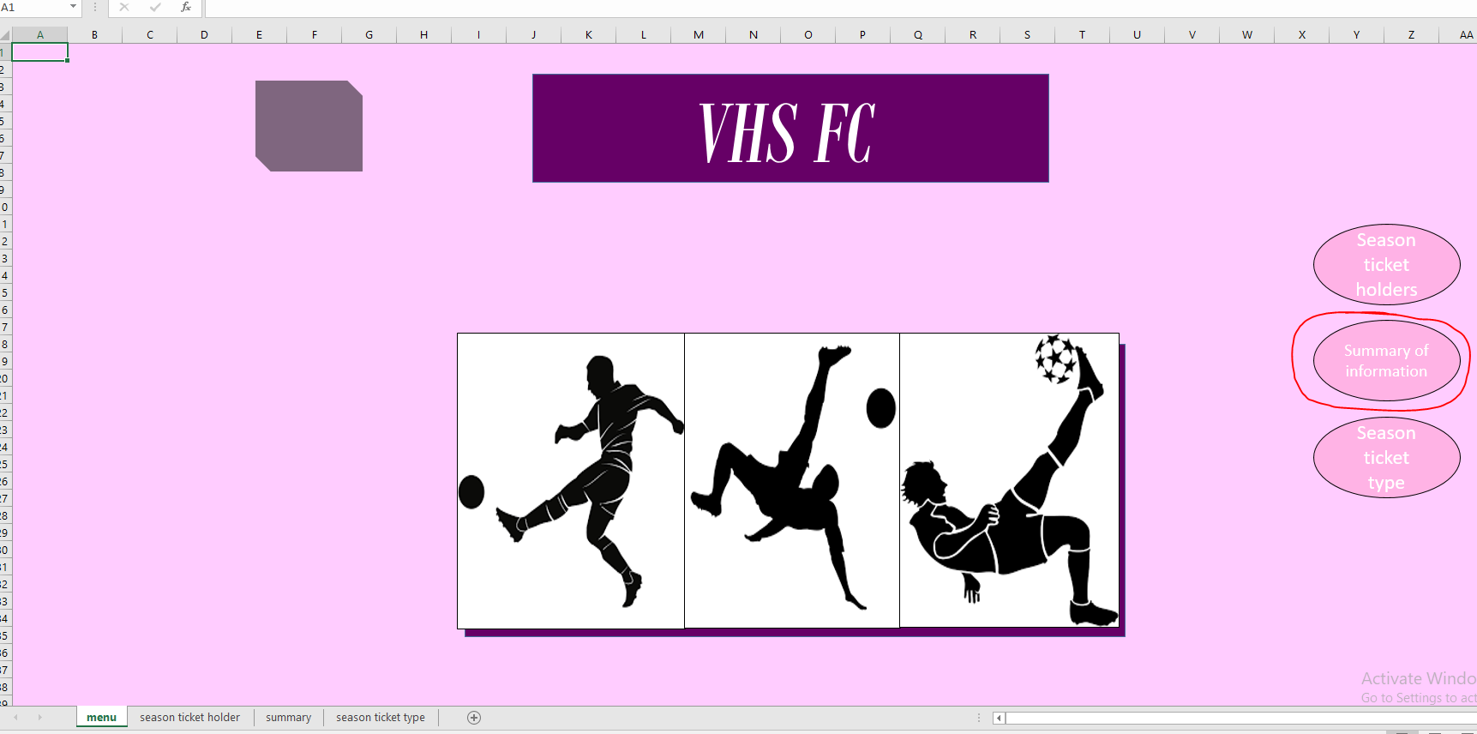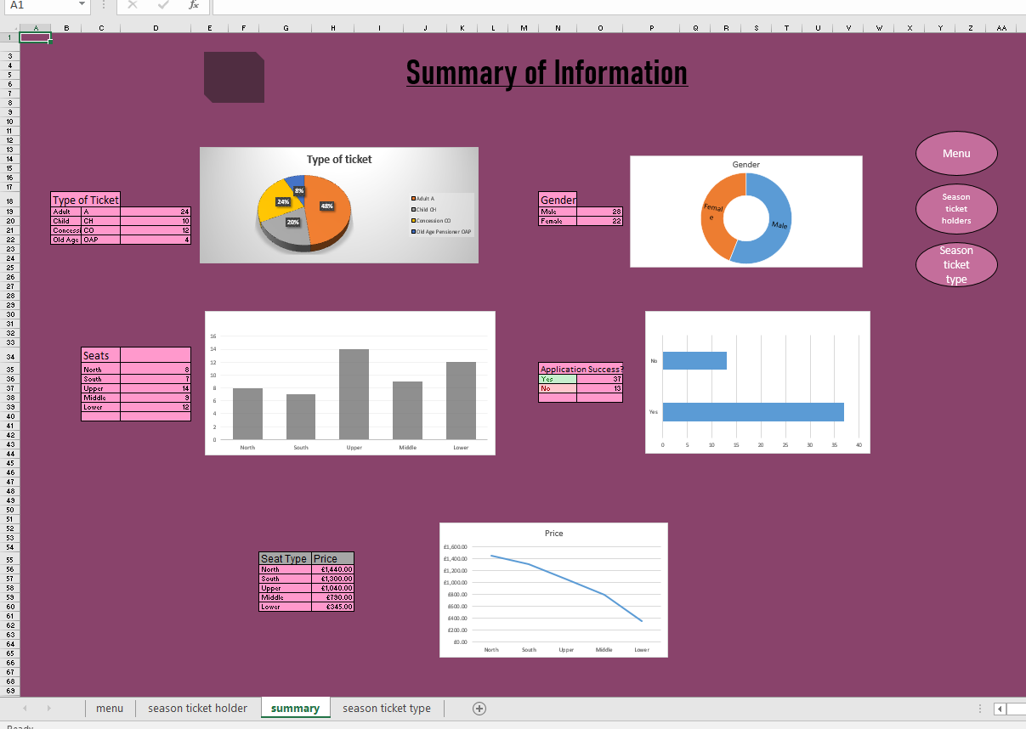 | N/A
2 | Input and error messages | See if it tells me what to input and make an error to see if the message comes up | 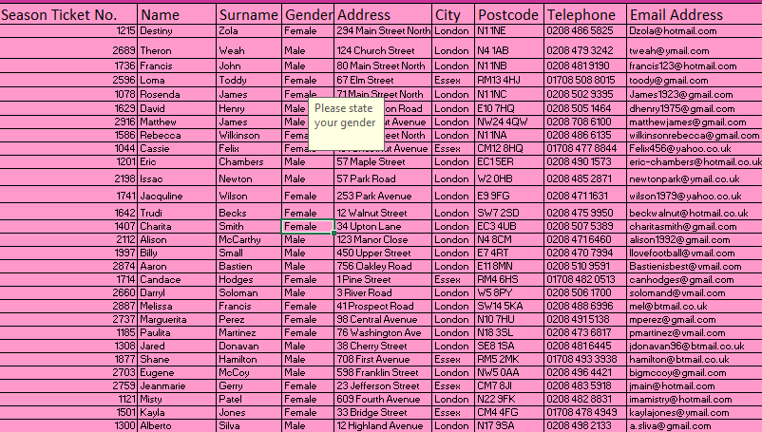  The error here was that it gave me the input message but not the error message even though I added it | To fix this I will redo the data validation and see where I went wrong for it not to work.
3 | To see if all the graphs have the correct data | By comparing the data table and graph and see if they match | 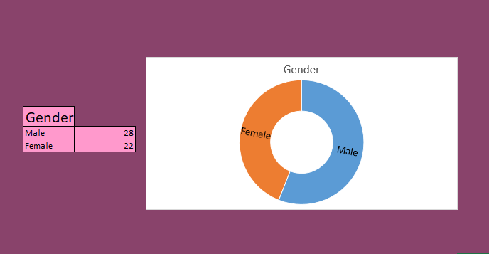  The error made here was that the graph has no data or any statistics so then the graph will be useless | To fix this I will go back to the graph and input the data using the data table beside it.
4 | Conditional formatting | By seeing if they are highlighted correctly | The error made here was that the yes and no was highlighted in the same colour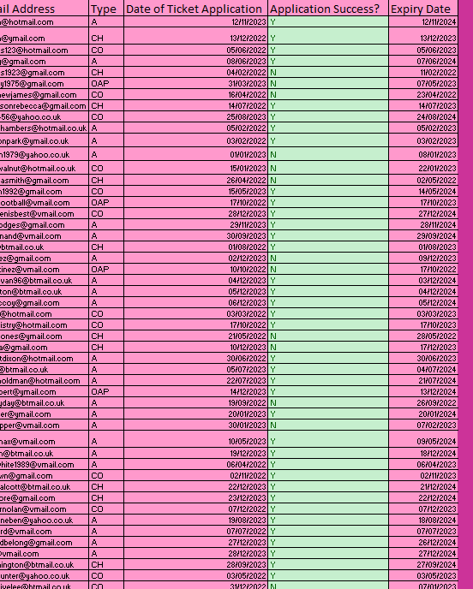 | Change the colours so it makes it less confusing

